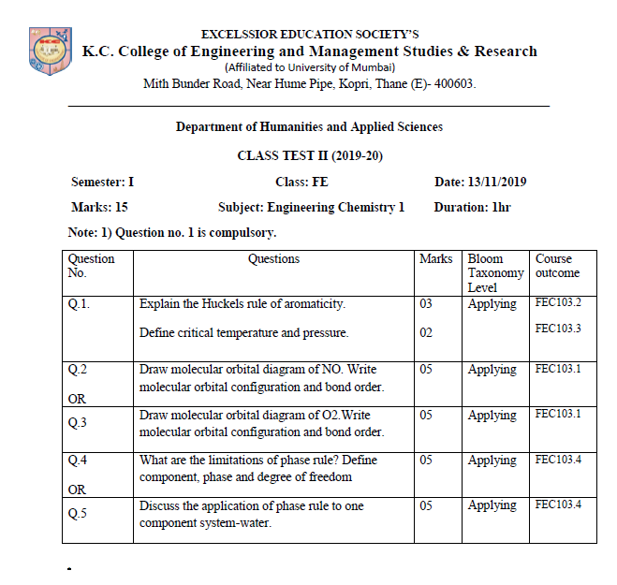

**Fig 8.4.1.3:** Sample Question Paper

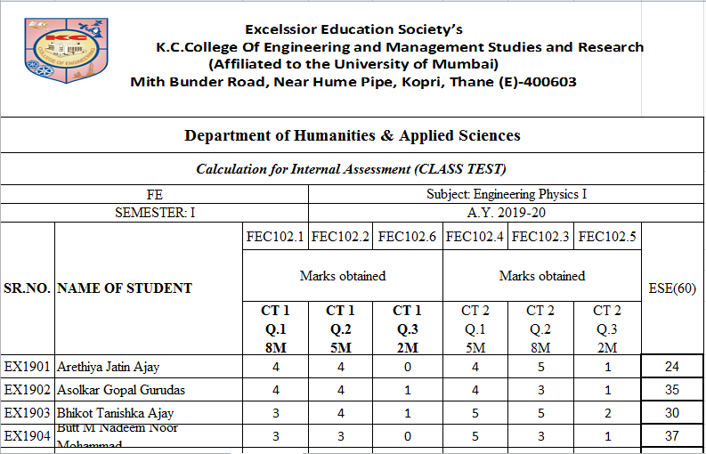

**Fig 8.4.1.4:** sample of entered class test marks of students (Internal Assessment calculations)

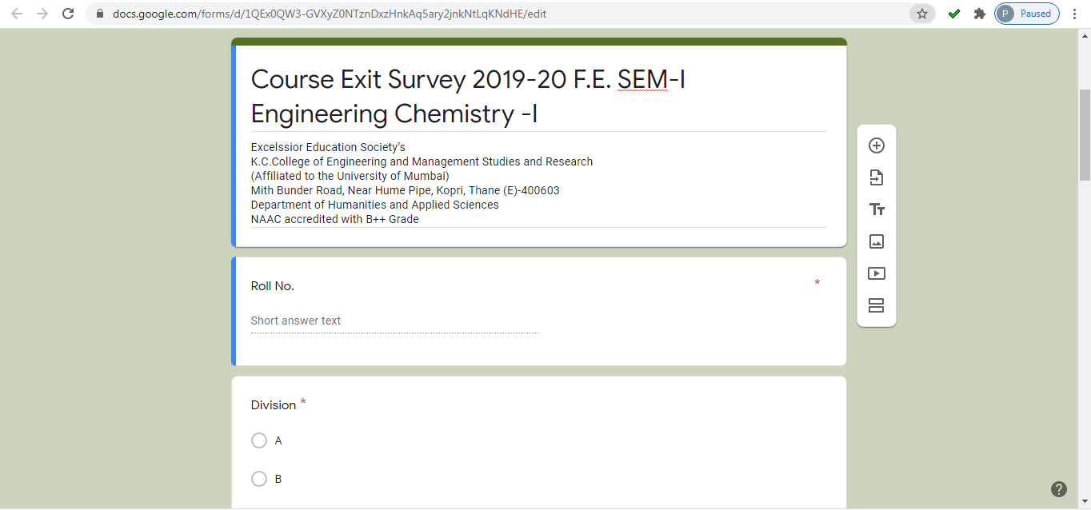

**Fig 8.4.1.7:** Sample Course Exit Survey Form

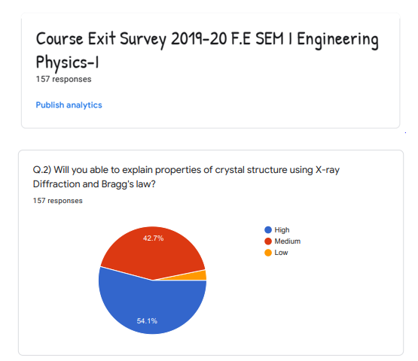

**Fig 8.4.1.8:** Sample Course Exit Survey

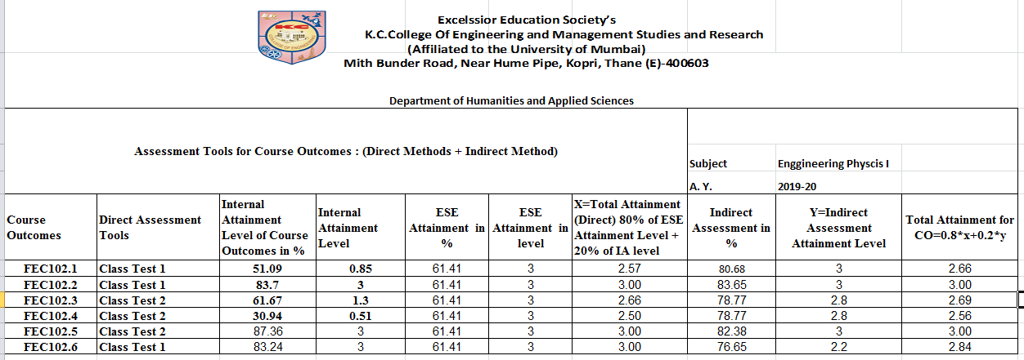

**Fig 8.4.10** Sample Summary Sheet (Final Attainment Calculation)